***Handling Requests and Responses the GET Request***

localhost:3000 is simply the same as the home page of any website like [www.google.com](http://www.google.com)

localhost:3000/ is the rit of the home page.

Like when we search [www.google.com/](http://www.google.com/) it goes to the home page.

<http://localhost:3000/> in google chrome

see lecture **3. Handling Requests and Responses the GET Request**

Now change send response back to the request, refresh the browser page and see the changes.

Note that the green data shown below comes when we change the js code in server while running it.

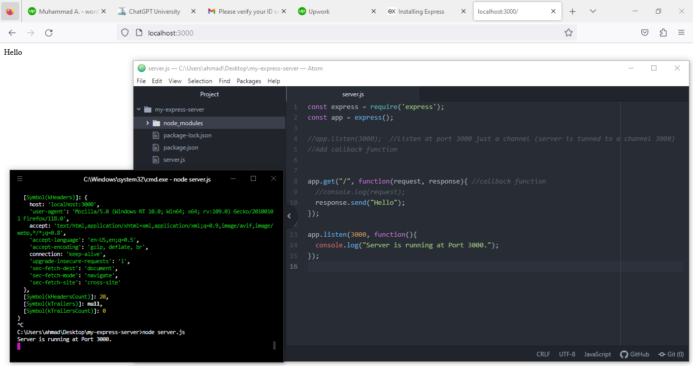

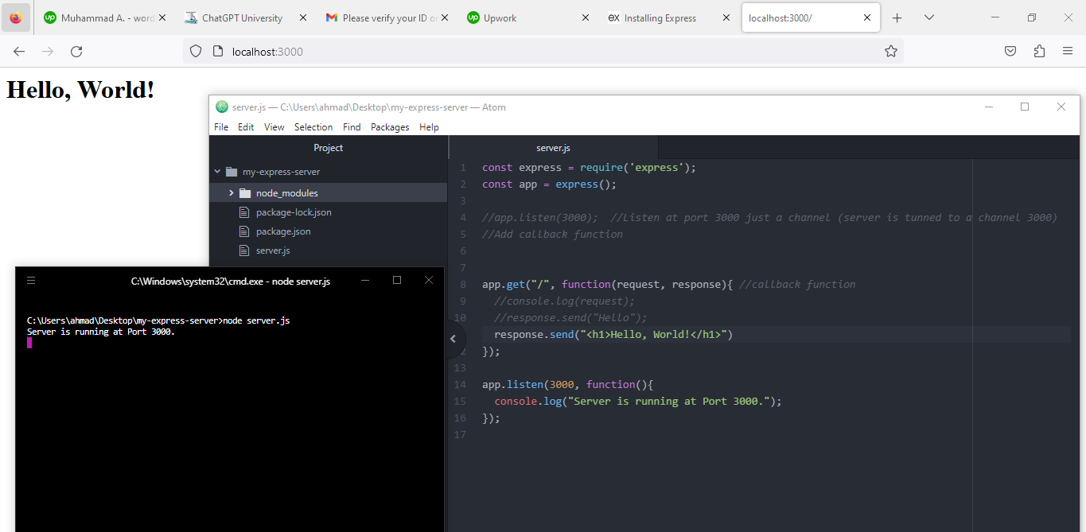

//jshint esversion:6

const express = require("express");

const app = express();

app.get('/',function(request,response){ //simply write re for request and res for response

//console.log(request);

response.send("<h1>Hello, World!</h1>");

}); //this method is present in express and allows what should happen when

//browser gets touch with the server @nd parameter is call back wunction

//app.listen(3000); //server is created

app.listen(3000, function(){

console.log("Server started on port 3000");

});